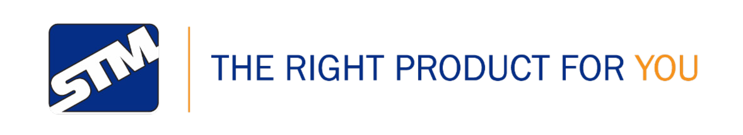

STM-WAT
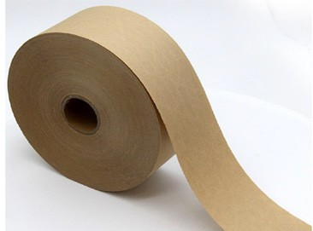

PRODUCT DESCRIPTION
- Water-activated adhesive
- Reinforced fiberglass diamond pattern
- Environmentally safe, non-pollutant
- Great for cardboard carton assembly
- Fully recyclable with corrugated cardboard

TYPICAL APPLICATIONS
Used for two strip sealing cartons top and bottom. Works well on recycled cartons, and non-unitized loads. Recommended for use on light weight to average cartons up to 31 pounds (14 kg).

SPECIFICATIONS
Natural
Polymeric Copolymer
Starch
5.5mils
Kraft Paper
Color:
Adhesive/Composite:
WAT Adhesive:
Total Thickness:
Backing:
STM-WAT Water-activated reinforced kraft paper tape is an environmentally responsible product. The base material and adhesive can be recycled with the packaging. It is mainly used to replace plastic backed pressure sensitive adhesive tapes used for carton sealing.

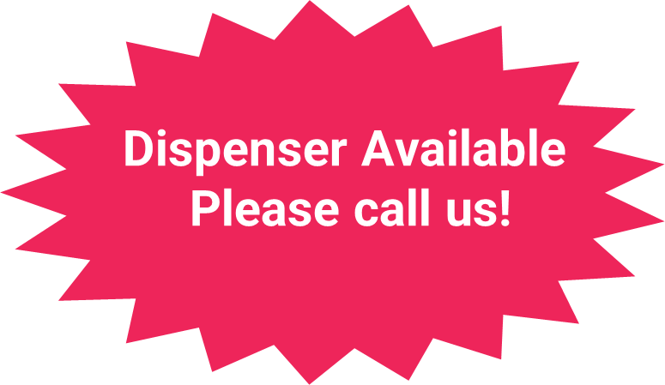
800-545-8273 | specialtytapes.net
sales@specialtytapes.net | Fax: 262-835-0749 | STM 4221 Courtney Road, Franksville, WI 53126 USA

